**Anthony Fairbanks Weston – Personal profile**

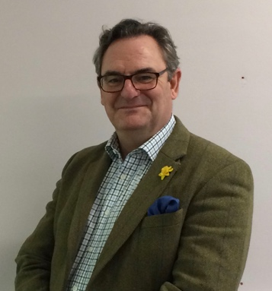  

***Short-listed - 2015 IFT Public Sector Transformation Award***

***Finalist – 2016 IFT Turnaround Professional of the Year***

After an early career in the Army, I have spent the last two decades forging a second career as an independent Turnaround Director and professional interim. Over this period I have undertaken a broad variety of board-level business transformation, turnaround and restructuring assignments across the public and private sectors, leading teams and making things happen.

I almost exclusively work with organisations that are facing significant operational and financial challenges on complex and sensitive high-profile restructuring and transformation programmes that have one thing in common: there is the opportunity to really *‘make a difference’ –* influencing and driving change, building and leading strong teams and delivering successful outcomes.

As someone once said to me ‘You don’t do boring, do you?’, which certainly rang true!  The more complex the environment, the more sensitive the issues, the greater and more rewarding the challenge. Here is a selection of recent assignments:

* Business advisory role with award winning food manufacturing business.
* Restructuring of a high profile Premier League Football Club in preparation for successful sale.
* Business recovery of three multi-site Further and Higher Education Colleges
* Restructuring and leading the communications, stakeholder relations and policy teams at the NPIA IMPACT Programme; a national ‘mission critical’ programme that would change the way the Police Service shared information;
* Leading high-level consultation exercise and strategic review for a rail industry client that would shape future strategy, operating models and delivery capability, leading to a restructuring of the UK operating divisions ;

* Merger of three training schools into single Joint Service training school and creation of the UK Defence Media Operations Centre.

I have worked with organisations as varied as the Ministry of Defence and our three armed services, the Police Service, the Fire Service and the NHS, the rail industry, The Equality and Human Rights Commission, two multi-site Further and Higher Education Colleges and a Premier League Football Club. Taking people on transformation journeys that have demanded the following skills:

* Clarity of thought and vision, strategic insight and robust planning, intellectual flexibility and the ability to assimilate information, assess situations and look for solutions;
* Strong, collaborative and inspirational leadership – setting the tone, providing direction and support, identifying talent, developing potential, galvanising, guiding and encouraging teams to succeed;
* Rigourous fincacial management and challenge – cost management, cost reduction, debt restructuring.
* Innovative and sustained stakeholder relations, engagement and communications; building and maintaining wide-ranging stakeholder relationships across complex multi-disciplinary and politically charged landscapes;
* The ability to engage, communicate and influence at all levels with integrity, tact and sensitivity; often reconciling conflicting positions and requirements;
* Self-belief, determination and resilience;
* Robust governance, progress reporting and programme management;
* A ‘can-do attitude’ and the ability to enthuse and motivate others; encouraging them to challenge embedded practices and, above all, look for solutions.

For me ‘success’ is about facilitating and enabling businesses and organisations to move forward with confidence by working with them to address the challenges to transformation, and develop and implement business and people solutions that will deliver optimal, sustainable and cost effective operations.

BUSINESS TRANSFORMATION, BUSINESS RECOVERY

RESTRUCTURING AND TURNAROUND



*The IFT is the leading professional body for accredited experts*

*in turnaround and transformation*